Rent Ease: House Rental Management System

1. INTRODUCTION
1.1 Project Overview
Rent Ease: House Rental Management System is a web-based application designed to simplify the process of renting and managing houses using modern web technologies. The system enables renters to search and book rental properties, while property owners can list and manage their houses efficiently. By leveraging the MERN stack (MongoDB, Express.js, React.js, Node.js), the application ensures scalability, security, and ease of use.
The core idea of Rent Ease is to eliminate the dependency on brokers and manual processes by providing a centralized digital platform that connects renters, owners, and administrators, improving transparency and efficiency in the rental process.

1.2 Purpose
The purpose of this project is to develop an efficient, scalable, and user-friendly house rental management system. The application is intended to help renters find suitable houses easily and assist property owners in managing listings and bookings digitally. Rent Ease aims to reduce time, cost, and effort involved in traditional house rental methods.

2. IDEATION PHASE
2.1 Problem Statement
The traditional house rental process is mostly manual and unorganized. Renters face difficulty in finding genuine rental houses, while owners struggle to manage property listings and booking requests efficiently. The lack of a centralized system leads to miscommunication, lack of transparency, and dependency on intermediaries. There is a need for a reliable digital platform that simplifies rental management.

2.2 Empathy Map Canvas
Says: “I want to find a rental house easily.”
Thinks: “Is this property genuine and available?”
Does: Searches online, contacts owners or brokers.
Feels: Frustrated due to unclear information and delays.

2.3 Brainstorming
• Develop a MERN stack-based house rental application
• Create role-based access for renter, owner, and admin
• Enable property listing with images and details
• Implement booking and approval workflow
• Provide an admin dashboard for system monitoring

3. REQUIREMENT ANALYSIS
3.1 Customer Journey Map
Discover – Search rental houses – Interested – Easy navigation
Engage – View property details – Confident – Clear listing interface
Book – Send booking request – Hopeful – Booking status update

3.2 Solution Requirement
Functional:
User registration and login, property listing, property search, booking request, booking approval.
Non-functional:
Fast response time, secure authentication, user-friendly UI, scalable architecture.

3.3 Data Flow Diagram
- User registers or logs in
- User searches or lists properties
- Property data stored in database
- Booking request sent by renter
- Owner approves or rejects booking
- Booking status displayed to user

3.4 Technology Stack
• Frontend: React.js, HTML, CSS, Bootstrap
• Backend: Node.js, Express.js
• Database: MongoDB
• Authentication: JWT, bcrypt
• Tools: VS Code, Postman, MongoDB Compass

4. PROJECT DESIGN
4.1 Problem Solution Fit
Manual house rental management requires significant time and coordination. Rent Ease provides a centralized digital solution that simplifies property listing, booking, and management. The system reduces manual effort and improves transparency, making it practical and cost-effective for both renters and owners.

4.2 Proposed Solution
• Develop a MERN stack-based rental management system
• Implement secure user authentication and role-based access
• Enable property listing with images and detailed descriptions
• Provide booking request and approval mechanism

4.3 Solution Architecture
The system follows a client–server architecture where the React frontend interacts with a Node.js and Express.js backend through REST APIs. MongoDB is used for storing user, property, and booking data securely. JWT ensures secure authentication and authorization.
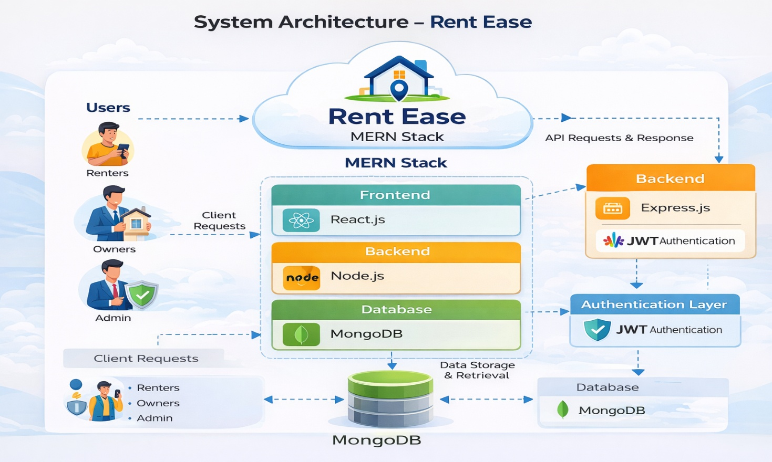
5. PROJECT PLANNING & SCHEDULING
5.1 Project Planning
Week 1 – Requirement analysis and database design
Week 2 – Backend development and API creation
Week 3 – Frontend development and integration
Week 4 – Testing, bug fixing, and deployment preparation

6. FUNCTIONAL AND PERFORMANCE TESTING
6.1 Performance Testing
• API Response Time: < 2 seconds
• Concurrent Users: Supported
• Secure login and booking operations
• Performance measured using response time and error handling

7. RESULTS
7.1 Output Screenshots
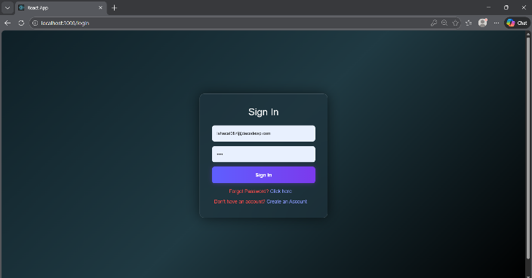
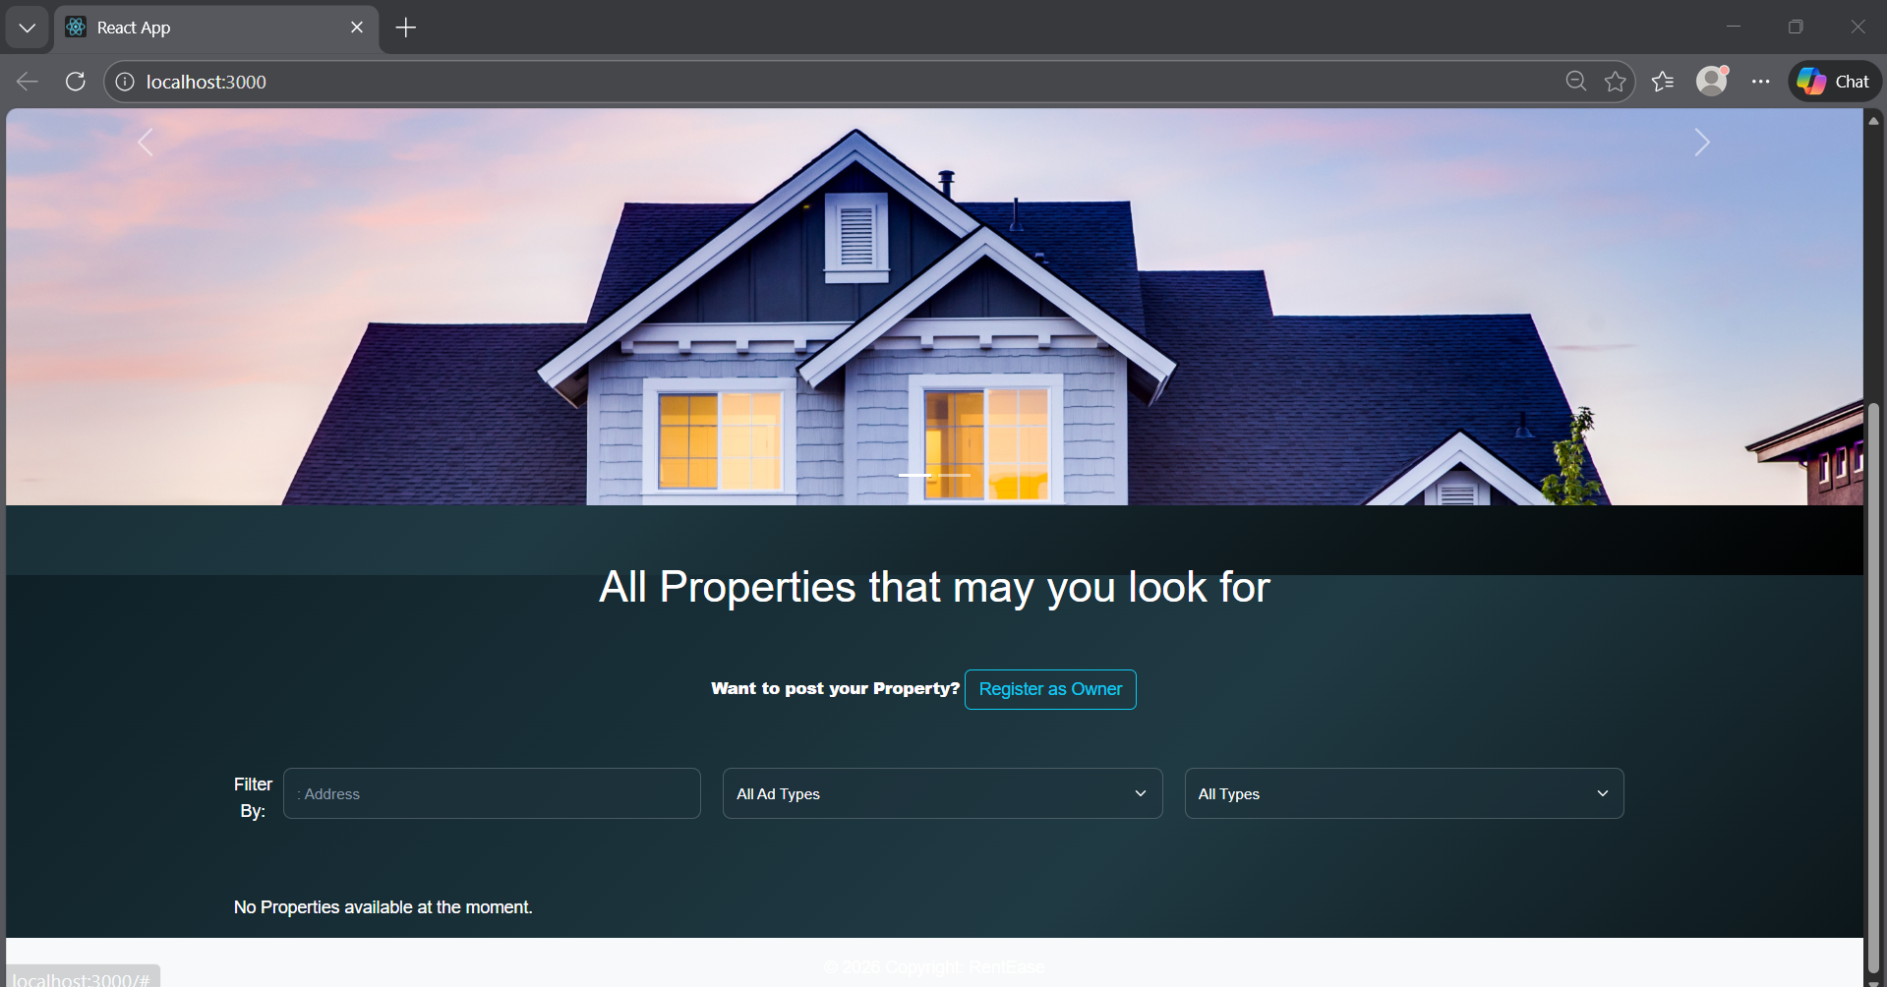
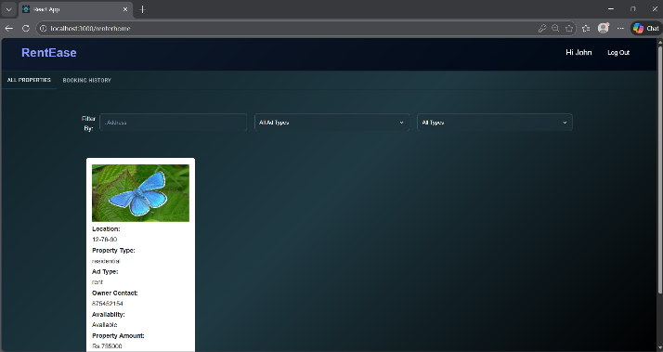
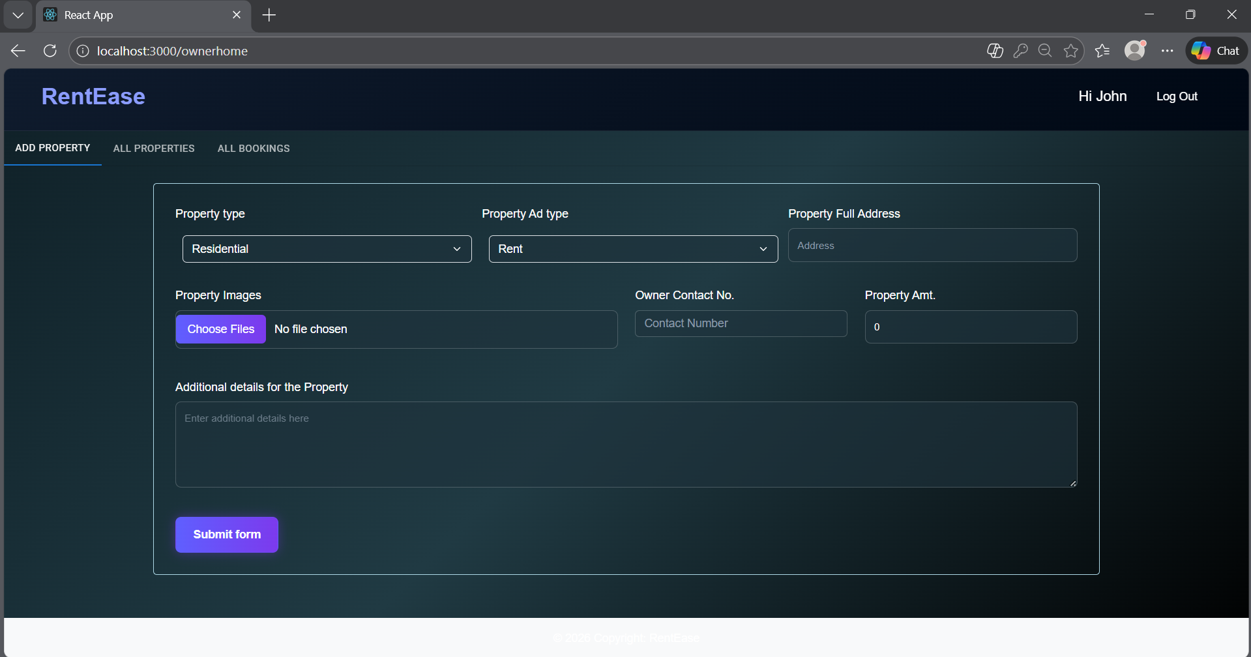
- ADVANTAGES & DISADVANTAGES
Advantages
• Reduces dependency on brokers
• Saves time and effort
• Centralized property management
• Secure and scalable system
Disadvantages
• Requires internet connectivity
• Limited features in initial version
• Payment integration not included

9. CONCLUSION
Rent Ease successfully provides a digital solution for house rental management by connecting renters and property owners through a secure web application. The system improves efficiency, transparency, and user experience, demonstrating the effectiveness of modern web technologies in solving real-world problems.

10. FUTURE SCOPE
• Mobile application development
• Online rent payment integration
• Real-time chat between renter and owner
• Recommendation system for properties
• Cloud deployment for large-scale usage

REFERENCES
MERN Stack Documentation
https://react.dev
https://nodejs.org
https://expressjs.com
https://www.mongodb.com
GitHub Repository:
https://github.com/kiranp1674/HouseHunt-Finding-Your-Perfect-Rental-Home
Project video Demonstration link:
https://youtu.be/5gZB6M0eZDQ

